**SOFTWARE REQUIREMENT SPECIFICATION**

**DOCUMENT**

**SIMPLE CALCULATOR SYSTEM**

**Version:** Version 1.2

**ABSTRACT**

This document is intended to be the SRS for develop **SIMPLE CALCULATOR SYSTEM**

|  |  |  |  |
| --- | --- | --- | --- |
| Project Title | SIMPLE CALCULATOR SYSTEM | | |
| Lead Institution | **THE INTERNATIONAL SCHOOL - DUY TAN UNIVERSITY** | | |
| Project Mentor | **Mr. Nguyen Dang Quang Huy** | | |
| Team Name | **Team 01** | | |
| Team Members | **Ngo Thi Tuyet Nhung** | | |
| **Huynh Thi My Duyen** | | |
| **Nguyen Van Dung** | | |
| **Ngo Nguyen Truong An**  **Truong Tan Loc** | | |
|  | | |
| Start Date | Jan 20, 2024 | **End Date** | Jan 27, 2024 |

**ROPRIETARY INFORMATION**: The information contained in this document is the property of **TEAM 01**. Except as specifically authorized in writing by **TEAM 01**, the holder of this document shall keep all information contained herein confidential and shall protect same in whole or in part from disclosure and dissemination to all third parties

**Table of Contents**

Revision History 3

1. Introduction 5

1.1. Purpose 5

This document describes a simple calculator system including all the necessary information and detailed documentation for implementation. The purpose of this document is as follows: 5

• Support users in calculating effectively and quickly 5

• To describe in detail the architectural drivers and use cases. Based on this documentation, the architectural analyst and designer will be able to implement the system with ease. 5

• Assist testers (QC) in writing acceptance tests and test plans. 5

Intended Audience and Reading Suggestions 5

2. Project Overview 5

2.1. Project Description 5

2.2 Business Need 5

2.3 Project Analyst 6

2.3.1 Business Function Diagram 6

2.3.2 System Context Diagram 6

2.4 Software Requirement Specification 7

2.4.1 High level Functional Requirement (FR) 7

2.4.2 Stakeholders 8

2.4.3 Use Case 9

2.4.4 List of use case 9

10

2.5. Software Design Description 20

2.5.1 . Activity Diagrams 20

Appendix A: Glossary 20

# Revision History

|  |  |  |  |  |
| --- | --- | --- | --- | --- |
| Date | Change Item | Description | By | Version |
| 20/01/2024 | Get requests from customers | After preparing the questions about the request and received the request from the customer | Huynh Thi My Duyen | Version 1.0 |
| 22/01/2024 | Start team meeting | Meet and refer to a number of training points, read through the training points and focus on project implementation, the team can fully understand the system requirements to create | Ngo Thi Tuyet Nhung, Huynh Thi My Duyen,  Nguyen Van Dung, Ngo Nguyen Truong An , Truong Tan Loc | Version 1.0 |
| 22/01/2024 | Job analysis | Through specific requirements, analysis, clearly speaking, the leader needs to prepare in advance for the members. | Ngo Thi Tuyet Nhung | Version 1.0 |
| 23/01/2024 | Share the work | Get BFD, contextual diagram, DFD level 1, DFD level 2,  The mandatory rules of the project | Ngo Thi Tuyet Nhung, Huynh Thi My Duyen,  Nguyen Van Dung, Ngo Nguyen Truong An , Truong Tan Loc | Version 1.0 |
| 24/01/2024 | Mr. Huy corrected | Fix BFD, DFD, USE CASE, font size, font pattern, context diagram, more clearly about the missing and suggest some important things | Truong Tan Loc | Version 1.0 |
| 25/01/2024 | Editing group | BFD, DFD, USE CASE, Context Diagram, font size, font | Ngo Thi Tuyet Nhung, Huynh Thi My Duyen,  Nguyen Van Dung, Ngo Nguyen Truong An , Truong Tan Loc | Version 1.0 |
| 26/01/2024 | Complete DFD, System Context Diagram | DFD 1 and 2, System Context Diagram | Ngo Thi Tuyet Nhung, Huynh Thi My Duyen,  Nguyen Van Dung, Ngo Nguyen Truong An , Truong Tan Loc | Version 1.0 |
|  |  |  |  |  |

# Introduction

## Purpose

## This document describes a simple calculator system including all the necessary information and detailed documentation for implementation. The purpose of this document is as follows:

## • Support users in calculating effectively and quickly

## • To describe in detail the architectural drivers and use cases. Based on this documentation, the architectural analyst and designer will be able to implement the system with ease.

## • Assist testers (QC) in writing acceptance tests and test plans.

## Intended Audience and Reading Suggestions

|  |  |
| --- | --- |
| Intended Audience | Reading Suggestions |
| **Project manager** | High level functional requirement, business constraints for estimation |
| **Architect analyst and designer** | Overall description and user cases to architect and design the system |
| **Quality control** | Overall description and user cases to make test plan and write acceptance test |
|  |  |

# Project Overview

## Project Description

Information technology has revolutionized human life and made life easier through various types of applications. With the rapid changes in the use of Information Technology, there are many tools, technologies and systems that have been produced and invented.

This project involves developing a simple Computer System for all types of users to make calculations more efficient and easier to handle. The computer system allows providing completely free computing services. The goal of this project is to bring simplicity and efficiency to users' calculations, while helping to save time in calculations, especially in business.

## Business Need

This system had a number of advantages:

- Support users in calculating faster and more efficiently

- Supports learning and business work for users to operate quickly

- The program fully meets user requirements and is capable of maintenance and upgrading.

- Easy to use interface**.**

## 2.3 Project Analyst

### Business Function Diagram

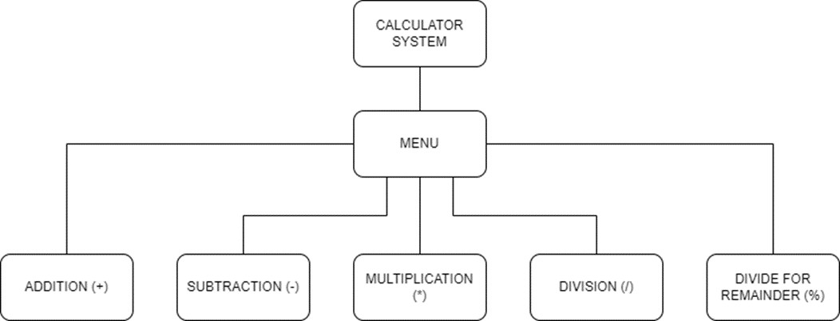

### System Context Diagram

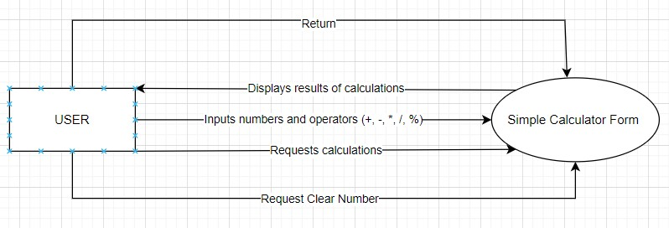

## Software Requirement Specification

### 2.4.1 High level Functional Requirement (FR)

|  |  |  |
| --- | --- | --- |
| FR1.1 | Title | Addition |
| User | This use case allows the user to perform the calculation of adding two numbers. |
| Description | The use case begins when the user wants to add two numbers in the system. The user enters two numbers to calculate in Number1 and Number2 to perform this action.  Then press the "+" button to perform the calculation.  The system will calculate and display the results to the user. |
| FR1.2 | **Title** | **Subtraction** |
| User | This use case allows the user to perform subtraction of two numbers. |
| Description | The use case begins when the user wants to add two numbers in the system. The user enters two numbers to calculate in Number1 and Number2 to perform this action.  Then press the "-" button to perform the calculation.  The system will calculate and display the results to the user. |
| FR1.3 | **Title** | **Multiplication** |
| User | This use case allows the user to perform multiplication of two numbers |
| Description | The use case begins when the user wants to add two numbers in the system. The user enters two numbers to calculate in Number1 and Number2 to perform this action.  Then press the "*" button to perform the calculation.  The system will calculate and display the results to the user |
| FR1.4 | **Title** | **Division** |
| User | This use case allows the user to perform division of two numbers |
| Description | The use case begins when the user wants to add two numbers in the system. The user enters two numbers to calculate in Number1 and Number2 to perform this action.  Then press the "/" button to perform the calculation.  The system will calculate and display the results to the user. |
| FR1.5 | **Title** | **Division to get remainder** |
| User | This use case allows the user to perform division to get remainder of two numbers |
| Description | The use case begins when the user wants to add two numbers in the system. The user enters two numbers to calculate in Number1 and Number2 to perform this action.  Then press the "%" button to perform the calculation.  The system will calculate and display the results to the user. |
| FR1.6 | **Title** | **Clear** |
| User | This use case allows the user to delete entered elements and results to perform another calculation. |
| Description | The use case begins when the user wants to delete everything to perform a new calculation. The user presses the "Clear" button to perform this operation.  The system will receive and display the worksheet back to the user. |
| FR1.7 | **Title** | **Return** |
| User | This use case allows the user to return back the menu to perform another calculation. |
| Description | The use case begins when the user wants to return back to the menu to choose a new calculation. The user presses the "Return" button to perform this operation.  The system will receive and display the menu to the user. |

### Stakeholders

|  |  |
| --- | --- |
| Stakeholder | Description |
| Users | System users |

### 2.4.3 Use Case

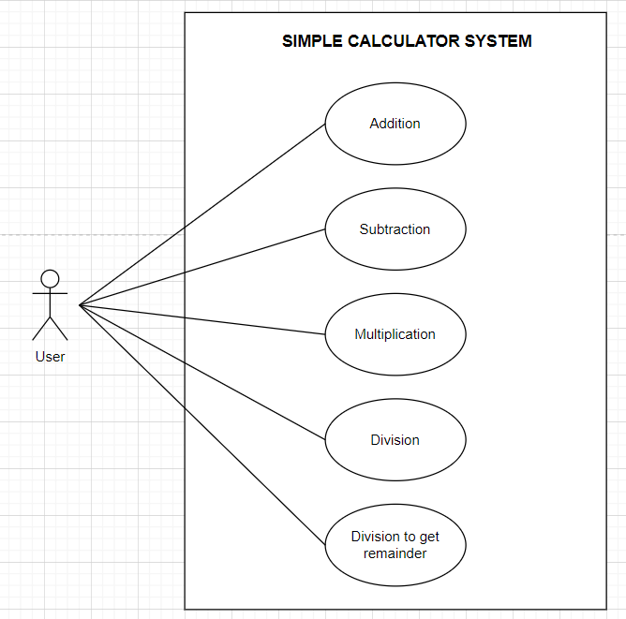

### List of use case

|  |  |  |
| --- | --- | --- |
| Use case ID | Use case name | Functional Req. |
| UC.01 | Addition | FR.1 |
| UC.02 | Subtraction | FR.2 |
| UC.03 | Multiplication | FR.3 |
| UC.04 | Division | FR.4 |
| UC.05 | Division to get remainder | FR.5 |
| UC.06 | Clear | FR.6 |
| UC.07 | Return | FR.7 |

**2.4.5. Use Case Specification**

**a) Use Case Diagram**

##### 

1. **Use Case Specification:**

* **UC.1: Addition**

|  |  |  |  |  |  |
| --- | --- | --- | --- | --- | --- |
| Use Case ID | 02UC.01 | | | | |
| Use case name | **Addition (+)** | | | | |
| Create by | Ngo Thi Tuyet Nhung | | **Last updated by** | | Ngo Thi Tuyet Nhung |
| Date created | Jan 22 ,2024 | | **Date last updated** | | Jan 22 ,2024 |
| Actor | User of the system | |  | | |
| Description | This use case outline the process for calculating the addition of two input numbers using “+” buttion. | | | | |
| Trigger | The user selects the “+” button form the calculator interface. | | | | |
| Pre-condition | The user has entered two numbers into the calculator. | | | | |
| Post-condition | The user is provided with the integer part of the addition. | | | | |
| Main Success Scenario: | **Step** | **Actor Action** | | **System Response** | |
| 1 | User enter two numbers into the Number1 and Number2 fields, respectively | | The interface will display the two numbers entered in the number1 and number2 fields respectively | |
|
| 2 | User click to **“+”** button | | The program will perform addition of the two numbers just entered and display the result on the screen.. | |
| Alternative Scenario | **Step** | **Actor Action** | | **System Response** | |
| 1 | User enter more than two numbers into the Number1 and Number2 fields, respectively | | The interface will display the two numbers entered in the number1 and number2 fields respectively | |
|
| 2 | User click to **“+”** button | | The interface will display the sum results of Number1 and Number2 | |
| Exceptions | **Step** | **Actor Action** | | **System Response** | |
| 1 | User entered characters into the Number1 or Number2. | | The interface will display the two numbers entered in the number1 and number2 fields respectively. | |
| 2 | User click to “+” button | | The interface will display “Error! Please re-enter the number.” | |
| Priority | High | | | | |
| Business rule | The “+” button should only be available for use after two valid numeric values have been entered into the calculator. | | | | |
| Description: | To utilize the “+” functionality, users first access the calculator and enter two valid numbers. Upon clicking the "+" button, the system seamlessly calculates and presents the desired results | | | | |

* **UC.02: Subtraction**

|  |  |  |  |  |  |
| --- | --- | --- | --- | --- | --- |
| UUse Case ID | UC.0202 | | | | |
| Use case name | **Subtraction (-)** | | | | |
| Create by | Huynh Thi My Duyen | | **Last updated by** | | Huynh Thi My Duyen |
| Date created | January 23, 2024 | | **Date last updated** | | January 23, 2024 |
| Actor | Users of the system | | | | |
| Description | This use case outline the process for calculating the integer subtraction of two input numbers using “-” button | | | | |
| Trigger | The user selects the “-” button from the calculator interface. | | | | |
| Pre-condition | The user has entered two numbers into the calculator. | | | | |
| Post-condition | The user is provided with the integer part of the subtraction. | | | | |
| Main Success Scenario: | **Step** | **Actor Action** | | **System Response** | |
| 1 | User enter two numbers into the Number 1 and Number 2 fields, respectively. | | The interface will display the two numbers entered in the Number 1 and Number 2 fields respectively. | |
| 2 | User click “-” button | | The program will perform integer subtraction of the two numbers just entered and display the result on the screen. | |
| Alternative Scenario | **Step** | **Actor Action** | | **System Response** | |
| 1 | Enter two numbers into the Number 1 and Number 2 fields, respectively. | | The interface will display the two numbers entered in the Number 1 and Number 2 fields respectively. | |
| 2 | Click to “-” button. | | The calculator displays an error message, prompting the user to enter valid values before performing. | |
| Exception | **Step** | **Actor Action** | | **System Response** | |
| 1 | The user enters a non-numeric value into one or both of the input fields. | | The calculator retrieves the inputs entered by the user | |
| 2 | Click “-” button. | | The calculator displays an error message, prompting the user to enter valid values before performing. | |
| Priority | High | | | | |
| Business rule | The “-” button should only be available for use after two valid values have been entered into the calculator. | | | | |
| Description: | To utilize the “-” functionality, users first access the calculator and enter two valid numbers. Upon clicking the “-” button, the system seamlessly calculates and presents the result. | | | | |

* **UC.03 : Multiplication**

|  |  |  |  |  |  |
| --- | --- | --- | --- | --- | --- |
| Use case ID | **UC.03** | | | | |
| Use case name | **Multiplication (*)** | | | | |
| Create by | Nguyen Van Dung | | **Last updated by** | | Nguyen Van Dung |
| Date created | January 23, 2024 | | **Date last updated** | | January 23,2024 |
| Actor | Users of the system | | | | |
| Description | This use case outlines the process for calculating the remainder of two input numbers using the "*" button. | | | | |
| Trigger | The user selects the "*" button from the calculator interface. | | | | |
| Pre-condition | The user has entered two numbers into the calculator. | | | | |
| Post-condition | The user is presented with the product of the multiplication operation. | | | | |
| Main Success Scenario: | **Step** | **Actor Action** | | **System Response** | |
| 1 | The user enters 2 numbers. | | The calculator retrieves the two numbers entered by the user | |
| 3 | Click “*” button. | | The calculator performs a multiplication operation then displays the product of multiplying to the user. | |
| Alternative Scenario | **Step** | **Actor Action** | | **System Response** | |
| 1 | The user enters more than two numbers into the calculator before selecting the "*" button. | | The calculator retrieves the numbers entered by the user | |
| 2 | Click “**\***” button. | | The calculator displays an error message, prompting the user to clear some of the input numbers before performing the multiplication calculation. | |
| Exception | **Step** | **Actor Action** | | **System Response** | |
| 1 | The user enters a non-numeric value into one or both input fields. | | The calculator retrieves the inputs entered by the user | |
| 2 | Click “**\***” button. | | The calculator displays an error message, prompting the user to enter valid numeric values before performing the multiplication calculation. | |
| Priority | High | | | | |
| Business rule | The "**\***" button should only be available for use after two valid numeric values have been entered into the calculator. | | | | |
| Description: | The multiplication operation is a fundamental function of a calculator. This use case describes the process of how a user can perform a multiplication operation using the calculator application. The calculator should be able to handle valid numeric inputs and provide appropriate responses for invalid inputs. The multiplication operation should only be performed when two valid numeric inputs are provided. If more than two numbers are entered, the calculator should prompt the user to clear some of the input numbers before performing the multiplication calculation. If a non-numeric value is entered, the calculator should prompt the user to enter valid numeric values. The priority of this use case is high due to the fundamental nature of the multiplication operation in a calculator application. The business rule ensures that the multiplication operation is only available when two valid numeric inputs are provided. This ensures the accuracy and reliability of the calculator application. | | | | |

* **UC.04: Division**

|  |  |  |  |  |  |
| --- | --- | --- | --- | --- | --- |
| Use Case ID | UC.04 | | | | |
| Use case name | **Division (/)** | | | | |
| Create by | Ngo Nguyen Truong An | | **Last updated by** | | Ngo Nguyen Truong An |
| Date created | January 22,2024 | | **Date last updated** | | January 22,2024 |
| Actor | User of the system | |  | | |
| Description | This use case outline the process for calculating the integer division of two input numbers using “/” button. | | | | |
| Trigger | The user selects the “/” button form the calculator interface. | | | | |
| Pre-condition | The user has entered two numbers into the calculator. | | | | |
| Post-condition | The user is provided with the integer part of the division. | | | | |
| Main Success Scenario: | **Step** | **Actor Action** | | **System Response** | |
| 1 | User enter two numbers into the Number1 and Number2 fields, respectively. | | The interface will display the two numbers entered in the Number1 and Number2 fields respectively. | |
| 2 | User click “/” button | | The program will perform integer division of the two numbers just entered and display the result on the screen. | |
| Alternative Scenario | **Step** | **Actor Action** | | **System Response** | |
| 1 | User enter more than two numbers into the Number1 and Number2 fields, respectively | | The interface will display the numbers entered in the Number1 and Number2 fields respectively. | |
| 2 | User click “/” button | | The interface will display an error message and request the user to input the numbers again. | |
| Exceptions | **Step** | **Actor Action** | | **System Response** | |
| 1 | User enter letters or symbols that are not numbers into the Number1 or Number2 fields | | The interface will display the information you just entered in the Number1 and Number2 fields respectively. | |
| 2 | User click “/” button | | The interface will display an error message and request the user to input the numbers again. | |
| Priority | High | | | | |
| Business rule |  | | | | |
| Description: | To use the "/" function, first the user accesses the computer and enters two valid numbers. When clicking the "/", the system will calculate and display the result of the integer division operation on the screen. | | | | |

* **UC.05: Division To Get Remainder**

|  |  |  |  |  |  |
| --- | --- | --- | --- | --- | --- |
| Use case ID | **UC.05** | | | | |
| Use case name | **Division for remainder (%)** | | | | |
| Create by | Truong Tan Loc | | **Last updated by** | | Truong Tan Loc |
| Date created | January 22, 2024 | | **Date last updated** | | January 22,2024 |
| Actor | Users of the system | | | | |
| Description | This use case outlines the process for calculating the remainder of two input numbers using the "%" button | | | | |
| Trigger | The user selects the "%" button from the calculator interface. | | | | |
| Pre-condition | The user has entered two numbers into the calculator. | | | | |
| Post-condition | The user is presented with the remainder of the division operation. | | | | |
| Main Success Scenario: | **Step** | **Actor Action** | | **System Response** | |
| 1 | The user enter 2 numbers. | | The calculator retrieves the two numbers entered by the user | |
| 3 | Click “**%**” button. | | The calculator performs a division operation then displays the remainder of the division operation to the user. | |
| Alternative Scenario | **Step** | **Actor Action** | | **System Response** | |
| 1 | The user enters more than two numbers into the calculator before selecting the "%" button. | | The calculator retrieves the numbers entered by the user | |
| 2 | Click “**%**” button. | | The calculator displays an error message, prompting the user to clear some of the input numbers before performing the remainder calculation. | |
| Exception | **Step** | **Actor Action** | | **System Response** | |
| 1 | The user enters a non-numeric value into one or both of the input fields. | | The calculator retrieves the inputs entered by the user | |
| 2 | Click “**%**” button. | | The calculator displays an error message, prompting the user to enter valid numeric values before performing the remainder calculation. | |
| Priority | High | | | | |
| Business rule | The "%" button should only be available for use after two valid numeric values have been entered into the calculator. | | | | |
| Description: | To utilize the "%" functionality, users first access the calculator and enter two valid numbers. Upon clicking the "%" button, the system seamlessly calculates and presents the desired remainder. | | | | |

* **UC.06: Clear function**

|  |  |  |  |  |  |
| --- | --- | --- | --- | --- | --- |
| Use case ID | **UC.06** | | | | |
| Use case name | Clear elements and result | | | | |
| Create by | Ngo Thi Tuyet Nhung | | **Last updated by** | | Ngo Thi Tuyet Nhung |
| Date created | January 23, 2024 | | **Date last updated** | | January 24,2024 |
| Actor | Users of the system | | | | |
| Description | This use case allows the user to delete entered elements and results to perform another calculation, using the “Clear” button | | | | |
| Trigger | The user selects the "Clear" button from the calculator interface. | | | | |
| Main Success Scenario: | **Step** | **Actor Action** | | **System Response** | |
| 1 | The user click “Clear” button. | | The calculator receives the user's commands and delete all entered elements and results so that the user can perform a new calculation | |
|
| Priority | High | | | | |
| Business rule | The "Clear" button used when the user wants to delete the newly entered data including answers. | | | | |
| Description: | "Clear" function, used by users when they want to clear everything to make a new calculation. When clicking the "Clear" button, the system will delete the entered elements and answers and then display a blank sheet to perform a new calculation. | | | | |

* **UC.07: Return function**

|  |  |  |  |  |  |
| --- | --- | --- | --- | --- | --- |
| Use case ID | **UC.07** | | | | |
| Use case name | Return back to menu | | | | |
| Create by | Huynh Thi My Duyen | | **Last updated by** | | Huynh Thi My Duyen |
| Date created | January 23, 2024 | | **Date last updated** | | January 24,2024 |
| Actor | Users of the system | | | | |
| Description | This use case allows the user to return back to menu to choose another calculation, using the “Return” button | | | | |
| Trigger | The user selects the "Return" button from the calculator interface. | | | | |
| Main Success Scenario: | **Step** | **Actor Action** | | **System Response** | |
| 1 | The user click “Return” button. | | The calculator receives the user's commands and display the menu so that the user can perform a new calculation | |
|
| Priority | High | | | | |
| Business rule | The "Return" button used when the user wants to return back to the menu | | | | |
| Description: | "Return" function, used by users when they want to return back to the menu to do a new calculation. When clicking the "Return" button, the system will display the menu to do a new calculation. | | | | |

## 2.5. Software Design Description

## 2.5.1 . Activity Diagrams

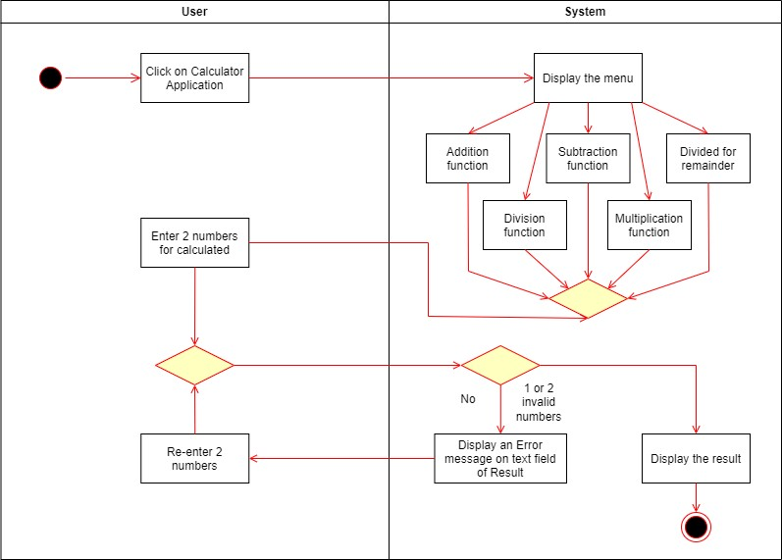

# Appendix A: Glossary

|  |  |
| --- | --- |
| **FR** | Functional Requirement |
| **QA** | Quality Attribute |
| **UC** | Use case |
| **BR** | Business rule |